**Ansible Assignment**

**Github Link:** [**https://github.com/saipragna25/saipragna-ansible.git**](https://github.com/saipragna25/saipragna-ansible.git)

**Submitted By**

**Sai Pragna Kancheti**

**016698552**

**Creating 3 VM’s using EC2 instances**

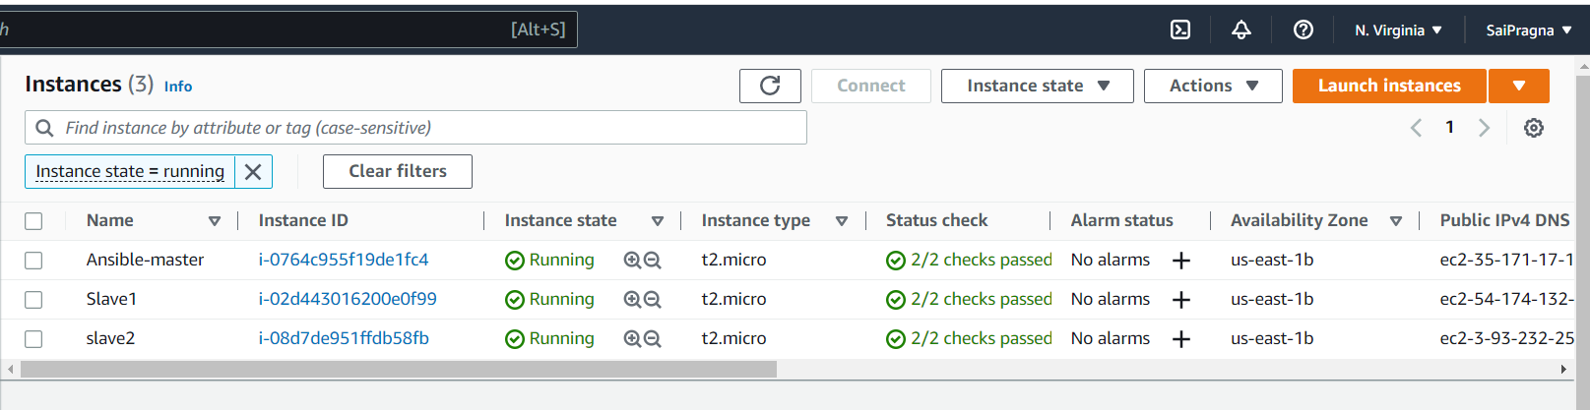

**Installing Ansible on Vm1**

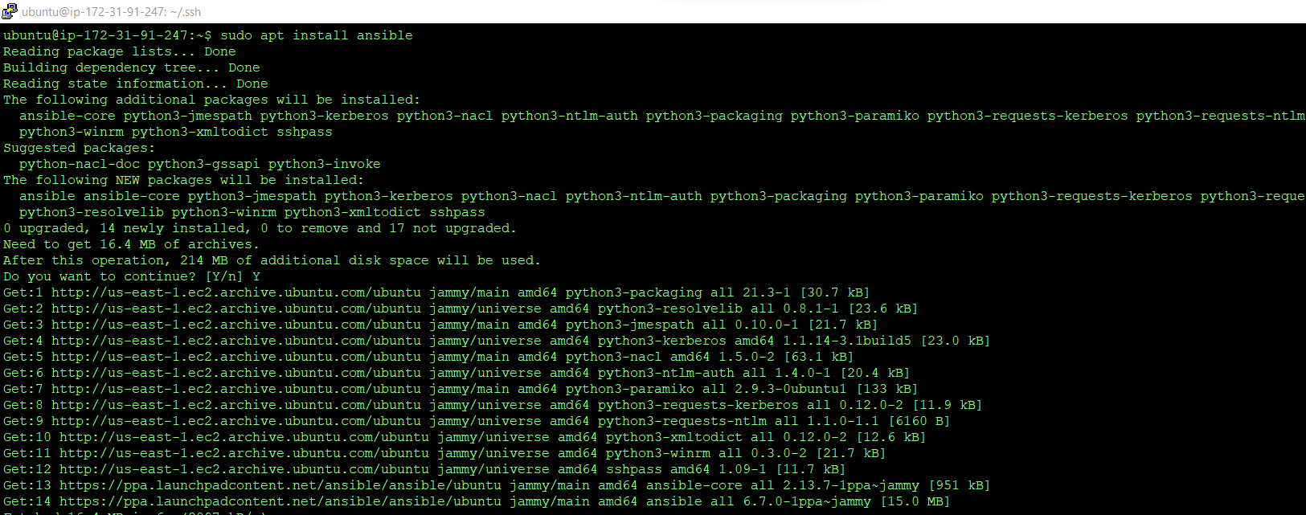

**Generating private key using ssh-keygen and adding them to other VM2, VM3**

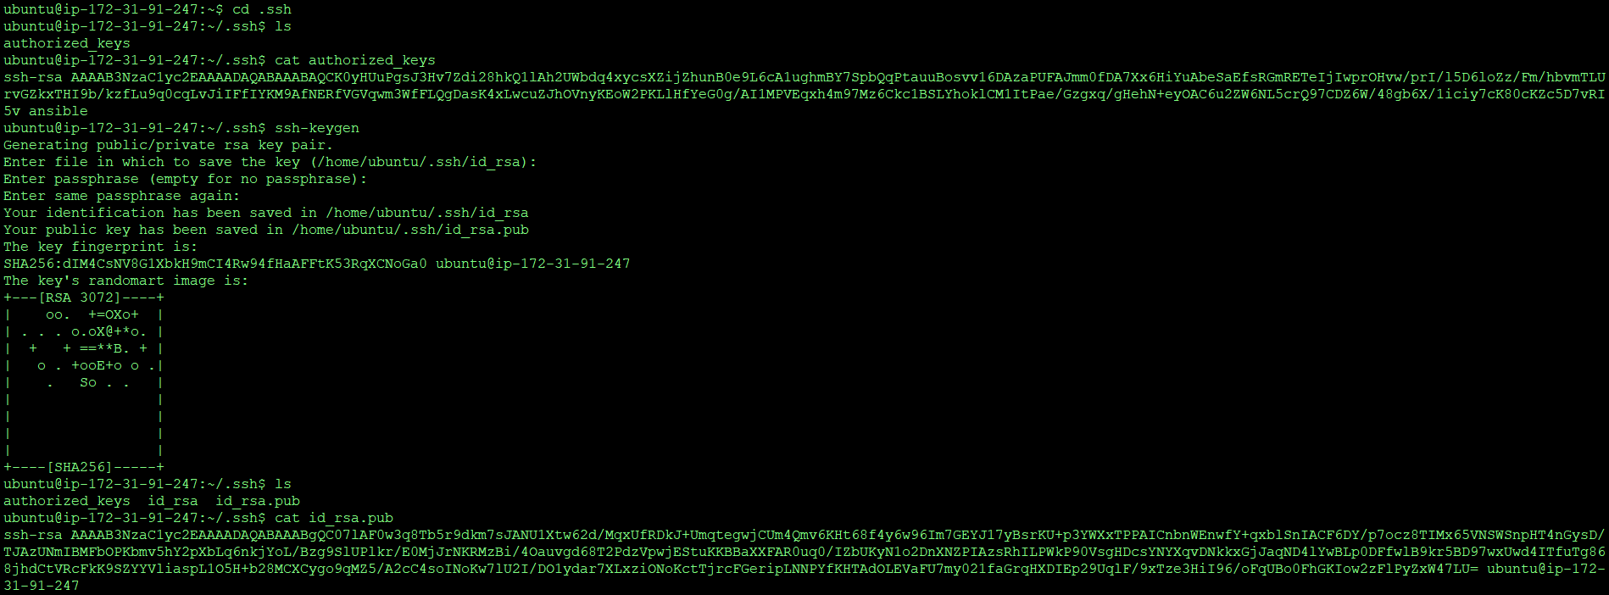

**Adding IP’s of slaves to host files**

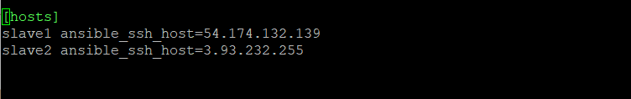

**Pinging other servers using ansible**



**Playbook to deploy ansible**

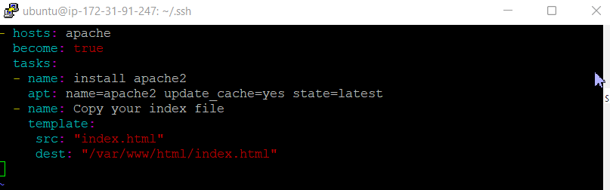

**Running playbook**

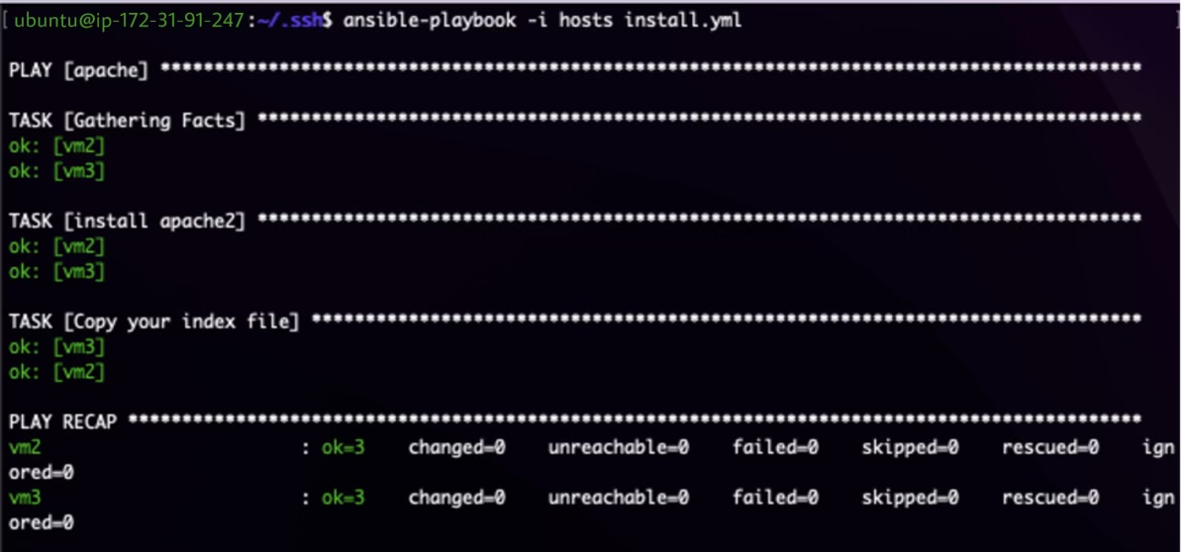

**After running playbooks**

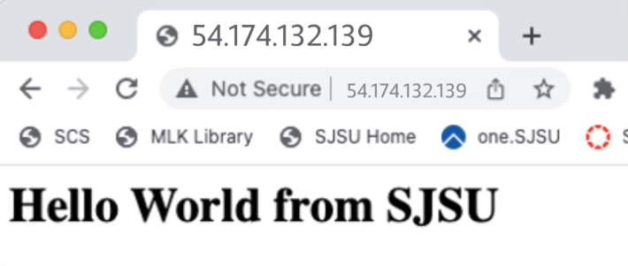

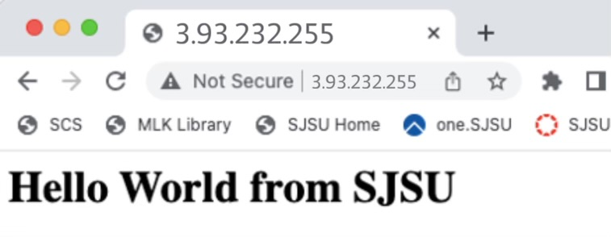

**Playbook to undeploy ansible**

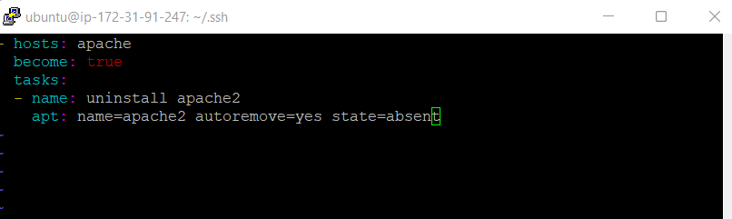

**Running the playbook**

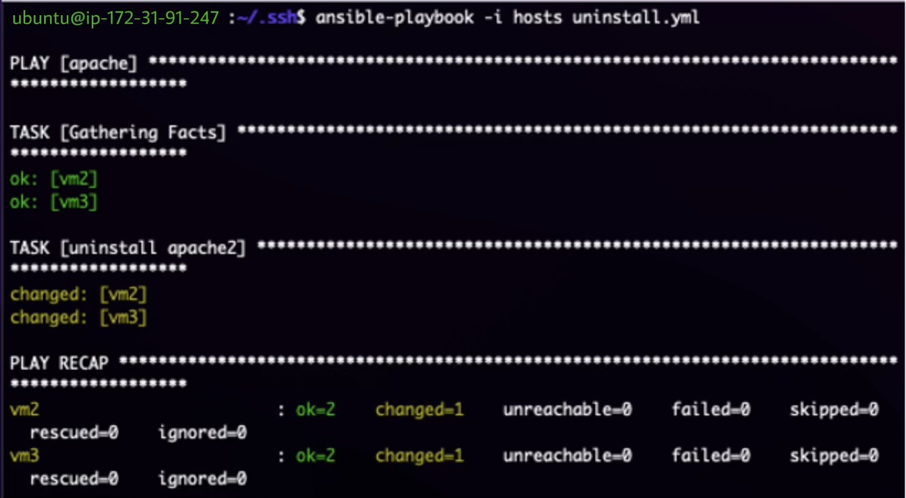

**After playing playbook**

